"Kyiv Vocational College of Communication"

Cyclic Commission of Computer Engineering

EXECUTION REPORT

**Work - Case #4**

**from the discipline: "Operating systems"**

**Topic:** WORK-CASES IN LINUX

a list of additional practical tasks

from the discipline "Operating Systems"

It was performed by students of the RPZ group - 03B

Team 6: Sichkar Maxim,

Brytyuk Bohdan

Kyiv 2023

**Work-case 4**

**In the course of work, it is often necessary to install new ones programs and applications. For this, it is necessary to be able to work with in the terminal by package managers:**

● Give a detailed definition of such concepts as "package" and

"repository".

A package is a file or collection of files that are used to install, update, or remove software on a computer system. Packages typically include the necessary files and instructions for installing the software and any dependencies it requires.

A repository is a collection of packages that are hosted in a central location and made available for installation on a computer system. These repositories are often managed by package managers, which are software tools that automate the process of downloading, installing, and managing software packages and their dependencies.

Package managers use repositories to download and install packages, as well as to check for updates and install new versions of software. This allows users to easily access and install new software without having to manually download and install each package and its dependencies. The use of repositories also helps to ensure that the software installed on a system is up-to-date and secure, as packages are regularly updated by the software developers and maintainers.

● Provide a brief overview of existing package managers in Linux.

There are several package managers available in Linux, including:

APT (Advanced Package Tool): APT is the default package manager for Debian-based distributions like Ubuntu, and it allows users to easily install, update, and remove software packages from the command line.

YUM (Yellowdog Updater, Modified): YUM is the default package manager for Red Hat-based distributions like Fedora, and it can be used to install, update, and remove software packages from the command line.

Pacman: Pacman is the package manager for Arch Linux and its derivatives. It is a simple and efficient tool for managing packages, and it can be used to install, upgrade, and remove packages.

Zypper: Zypper is the package manager for openSUSE and SUSE Linux Enterprise. It can be used to install, update, and remove packages from the command line.

Portage: Portage is the package manager for Gentoo Linux. It is a powerful tool that allows users to customize their system by compiling packages from source code.

These package managers make it easy to manage software packages on a Linux system and ensure that all dependencies are installed correctly. They are essential tools for any Linux user who needs to install new software or update existing software on their system.

Describe their main capabilities.

**2. Determine which package manager your Linux distribution uses.**

Describe the main commands for working with it:

● Search, download and install necessary packages, which are in your

the system does not exist (from the default repository, from a new repository, etc.).

To determine which package manager your Linux distribution uses, you can refer to the documentation or run the command cat /etc/*-release in the terminal and look for information about the package manager.

Here are some common Linux distributions and their corresponding package managers:

Debian and its derivatives (such as Ubuntu): APT (Advanced Package Tool)

Fedora and its derivatives (such as Red Hat and CentOS): DNF (Dandified YUM)

Arch Linux and its derivatives (such as Manjaro): Pacman

Here are some common commands for working with the APT package manager:

* sudo apt update: Update the package list from the repositories.
* sudo apt search package_name: Search for a package by name.
* sudo apt install package_name: Install a package.
* sudo apt remove package_name: Remove a package.
* sudo apt upgrade: Upgrade all installed packages to the latest version.
* sudo add-apt-repository repository_url: Add a new repository to the list of sources.

Here are some common commands for working with the DNF package manager:

* sudo dnf update: Update the package list from the repositories.
* sudo dnf search package_name: Search for a package by name.
* sudo dnf install package_name: Install a package.
* sudo dnf remove package_name: Remove a package.
* sudo dnf upgrade: Upgrade all installed packages to the latest version.
* sudo dnf config-manager --add-repo repository_url: Add a new repository to the list of sources.

Here are some common commands for working with the Pacman package manager:

* sudo pacman -Syy: Update the package list from the repositories.
* sudo pacman -S package_name: Install a package.
* sudo pacman -Rs package_name: Remove a package.
* sudo pacman -Syu: Upgrade all installed packages to the latest version.
* sudo pacman -Syyu: Update the package list and upgrade all installed packages.
* sudo pacman -S archlinux-keyring: Install the Arch Linux keyring to verify package signatures.
* sudo pacman -U package_file.tar.xz: Install a package from a local file.

Note: The commands may vary depending on the Linux distribution and the version of the package manager. It is always recommended to consult the documentation or the manual page (man apt, man dnf, man pacman) for more information on how to use these commands.

● View information about installed and available packages.

To determine which package manager your Linux distribution uses, you can check the documentation or run the command "cat /etc/release" in the terminal to find out the release information, including the package manager used.

Assuming the package manager is apt, which is commonly used in Debian-based distributions like Ubuntu, the main commands for working with it are:

View information about installed packages:

To list all installed packages: dpkg --list

To get detailed information about a specific installed package: dpkg --status <package_name>

To check if a package is installed: dpkg --get-selections | grep <package_name>

View information about available packages:

To update the package database: sudo apt update

To search for a package: apt search <package_name>

To get detailed information about a package: apt show <package_name>

To list all available packages: apt list

To list upgradable packages: apt list --upgradable

Install and remove packages:

To install a package: sudo apt install <package_name>

To remove a package: sudo apt remove <package_name>

To remove a package and its configuration files: sudo apt purge <package_name>

To clean up the package cache: sudo apt autoclean

These commands can be executed in the terminal or through a graphical package manager such as Synaptic or Ubuntu Software Center.

● Removal of unnecessary or outdated packages.

To determine which package manager your Linux distribution uses, you can check the documentation or run the command "cat /etc/os-release" in the terminal and look for the "ID" field.

Here are the main commands for removing unnecessary or outdated packages using some popular package managers:

APT (used by Debian, Ubuntu, and their derivatives):

To remove a specific package: "sudo apt remove [package_name]"

To remove a package and its configuration files: "sudo apt purge [package_name]"

To remove packages that are no longer required: "sudo apt autoremove"

YUM (used by Fedora, CentOS, and Red Hat Enterprise Linux):

To remove a specific package: "sudo yum remove [package_name]"

To remove a package and its configuration files: "sudo yum remove [package_name] --remove-leaves"

To remove packages that are no longer required: "sudo yum autoremove"

Pacman (used by Arch Linux and its derivatives):

To remove a specific package: "sudo pacman -R [package_name]"

To remove a package and its configuration files: "sudo pacman -Rn [package_name]"

To remove packages that are no longer required: "sudo pacman -Rs [package_name]"

● Update the package manager.

To determine which package manager your Linux distribution uses, you can consult the documentation or use the following command in the terminal:

cat /etc/os-release

This command will display information about the Linux distribution, including the package manager that it uses.

For example, in Ubuntu, the package manager is apt, which stands for Advanced Packaging Tool. The main command for updating the package manager in Ubuntu is:

sudo apt update

This command downloads the package lists from the repositories and updates them to get information about the latest version of packages available for installation. It does not actually upgrade the packages themselves.

Other Linux distributions may use different package managers, such as yum in Red Hat and CentOS, pacman in Arch Linux, or dnf in Fedora. The commands for updating the package manager may also be different for each distribution. It is important to consult the documentation or search for information specific to your distribution to ensure that you are using the correct commands.

**3. Install in the terminal through the package manager on your system:**

● A new video or audio player.

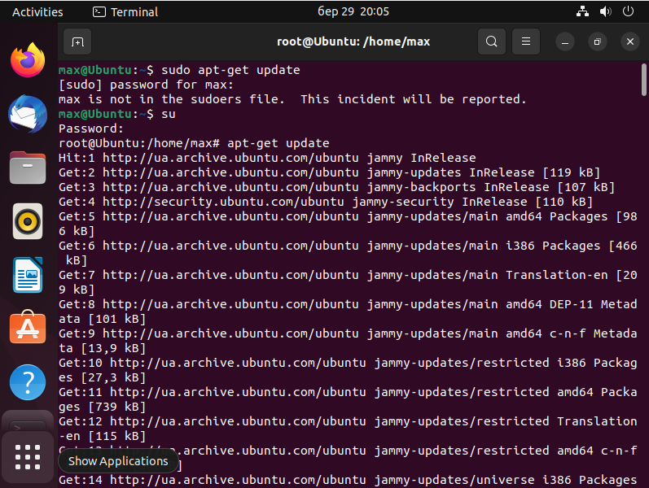

● An environment for the programming language you are learning.

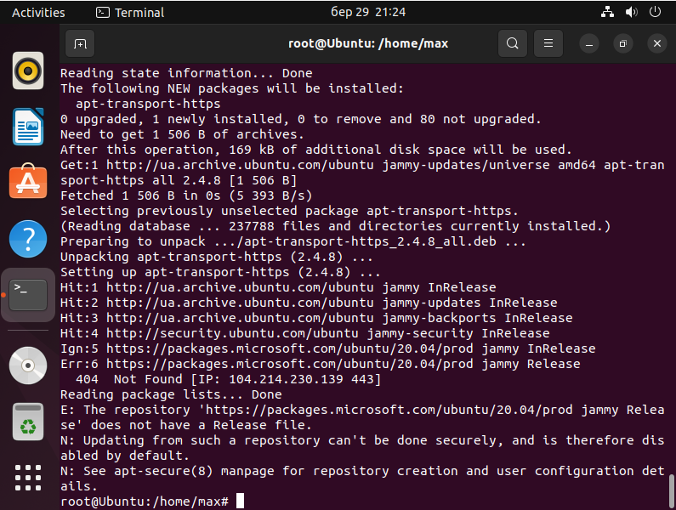

**4. How can you install new programs through application stores and**

**package managers in a graphical environment. Give your examples.**

In a graphical environment, you can install new programs through application stores and package managers using a user-friendly interface. Here are some examples:

Ubuntu Software Center - Ubuntu's default application store, which allows you to search, browse, and install various software packages. You can simply search for the desired program, select it, and click the "Install" button.

Synaptic Package Manager - A package manager for Ubuntu and other Debian-based distributions that provides a more advanced interface for managing software packages. You can use it to search for, install, and remove individual packages or groups of packages.

GNOME Software - A graphical package manager for GNOME-based Linux distributions that provides a similar interface to Ubuntu Software Center. You can browse software categories, search for specific packages, and install or remove them with a few clicks.

Discover - A package manager and software center for KDE-based Linux distributions, which provides a modern and intuitive interface for browsing, installing, and updating software packages.

Pacman - A package manager for Arch Linux and its derivatives, which can be used through the terminal or with a graphical frontend such as Pamac. You can use it to install, remove, and update packages from the official repositories or from the AUR (Arch User Repository).

Overall, graphical package managers and application stores provide an easy and convenient way to manage software packages in Linux, without having to use the command line.

Concludes: Operating systems are software that manage computer hardware and provide access to various functions and applications for users.

There are many different operating systems such as Windows, macOS, Linux, Android, etc. Each has its advantages and disadvantages, and the choice depends on the user's needs and personal preferences.